**Agile and Jira project (Daraz.com)**

1.Go to the URL “Daraz.com”



2. Change the language into Bangla



3. Create an issue, consisting with Project name, Issue type, Summary, Description, Assignee, Reporter, Attachment screenshots of bug and click on the Create button in JIRA.

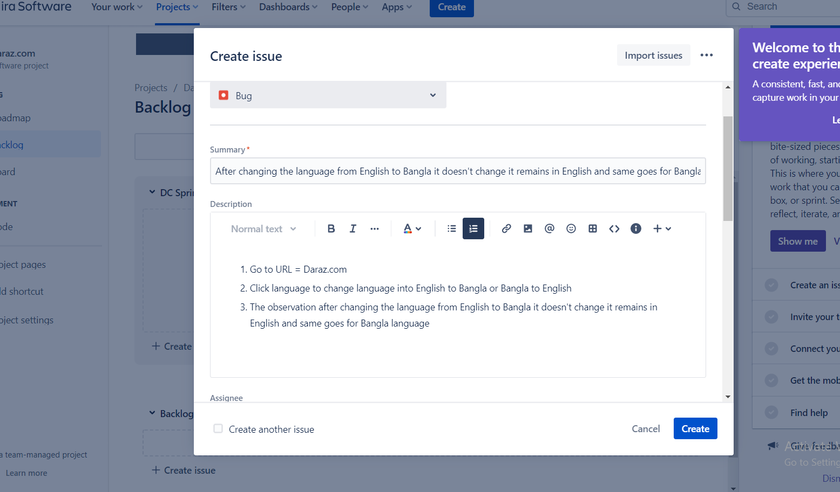

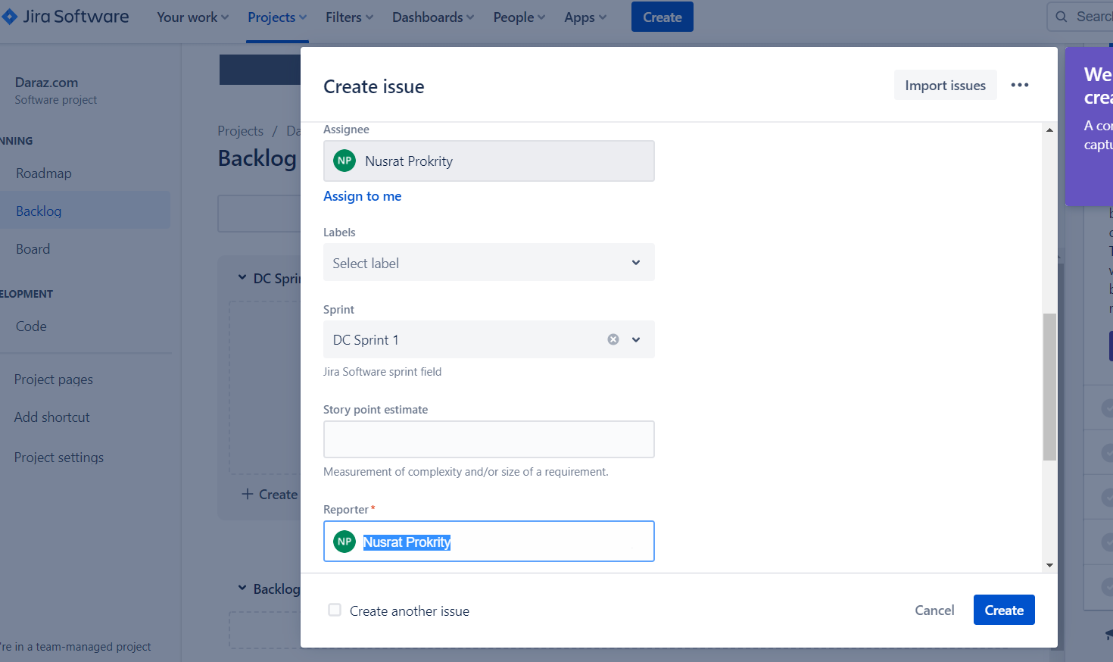

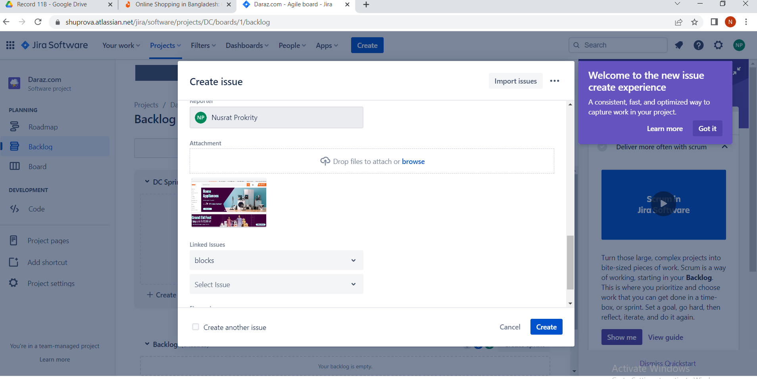

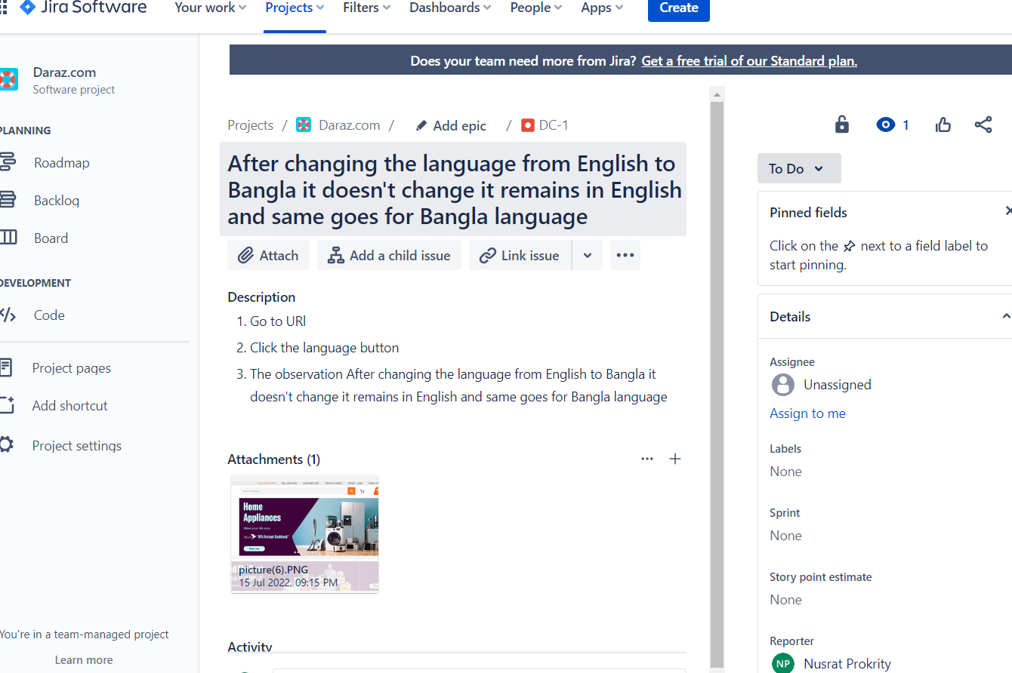

4. Start a sprint

5. Issue the sprint to developers

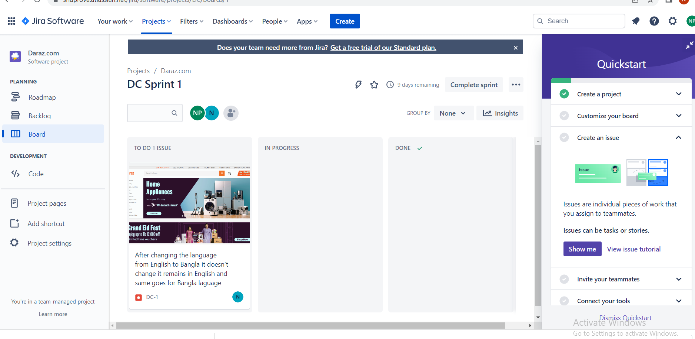

6. In progress

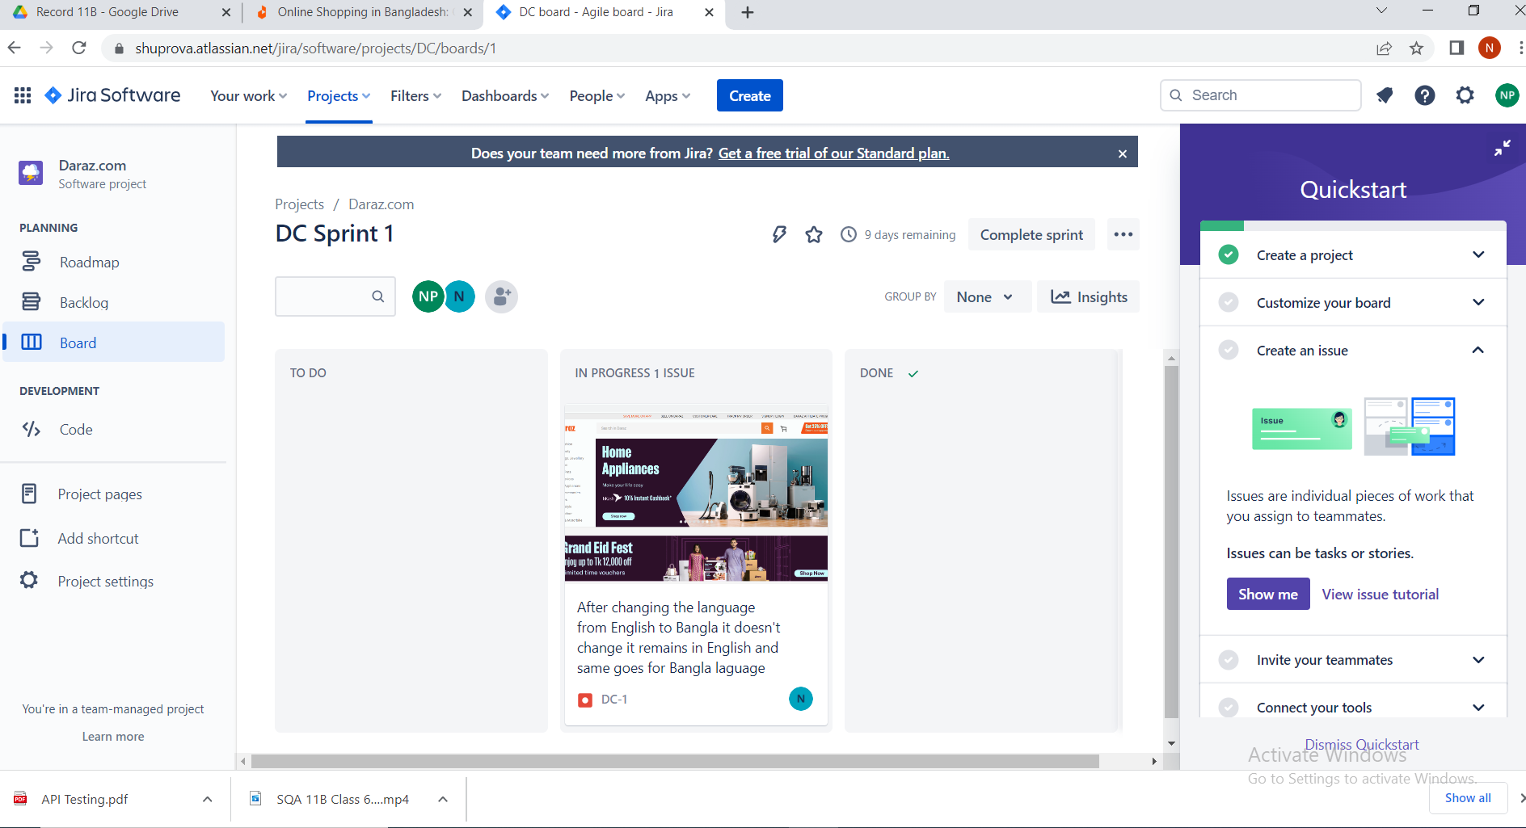

7. Done when the issue fixed

